# Module 1: Securing your tenant

# Exercise 1: Exploring existing Power Platform usage

## Scenario

In this exercise, you will be exploring the tenant to see what Power Platform assets have already been created. Specifically, you will be looking at the following:

* Environments that have been created
* Data Loss Prevention (DLP) policies.

### Task 1: Review existing environments

1. Logged in with the **Lab Admin account** in an in-private browser session navigate <https://aka.ms/ppac> and select **Environments**.
2. Review the list of environments. These are the environments that are available for you to manage.

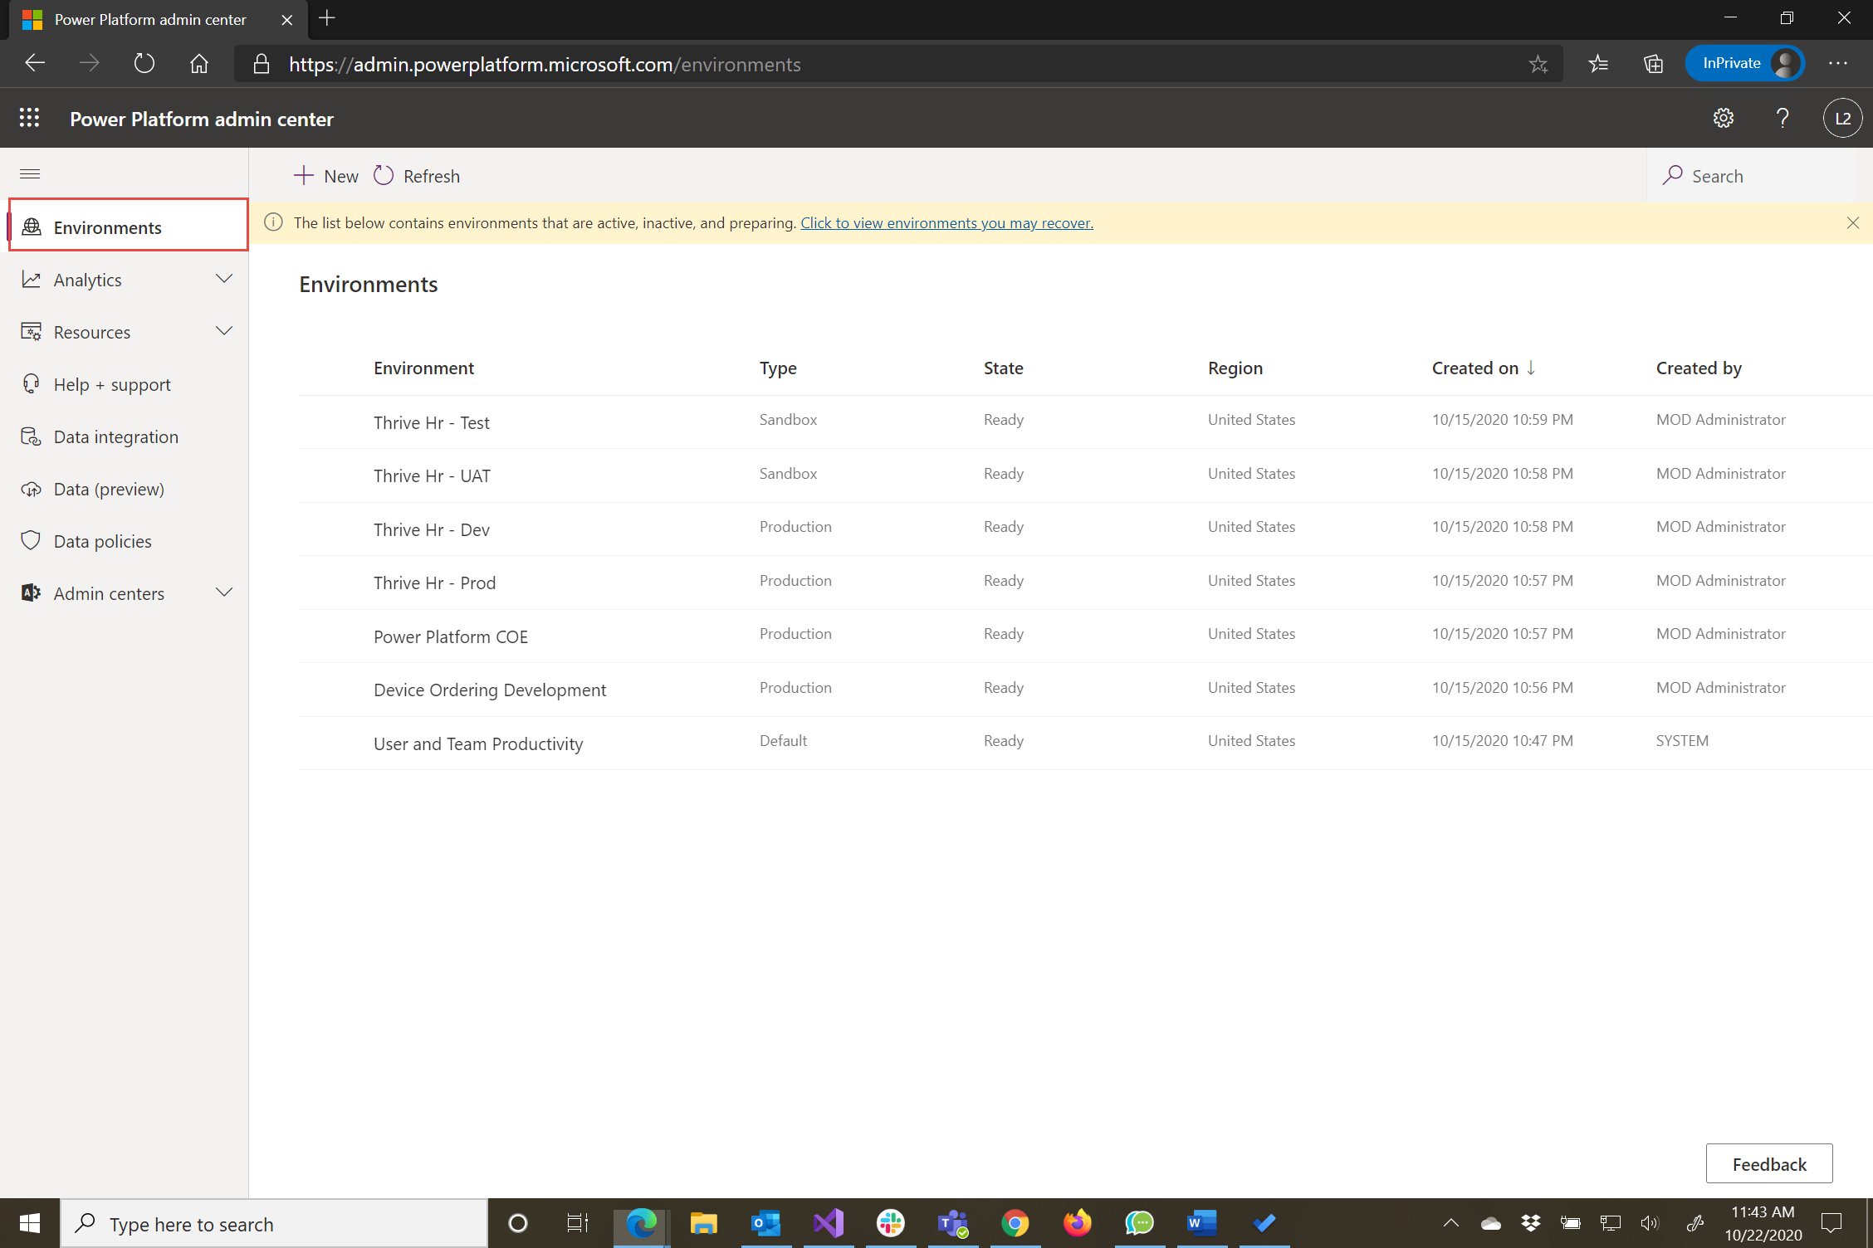

1. Notice the **type column**, you can see Fabrikam is already using several types of environments.
2. You can filter and order environments. Click on the **Type** column, select filter by **Production**, and click **Apply**.

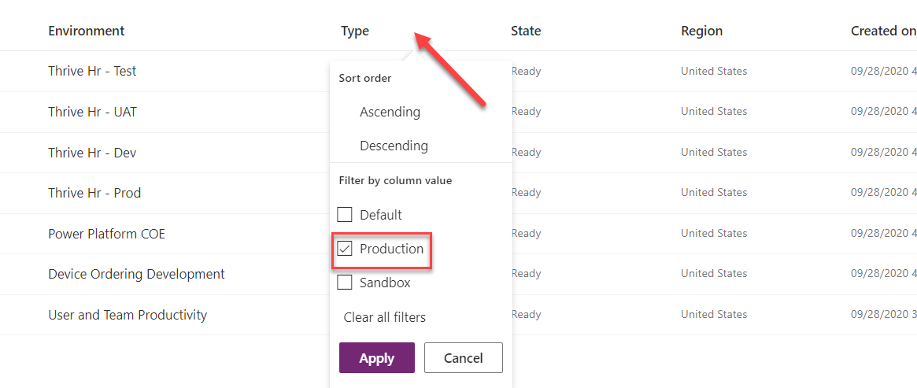

1. You should now see only the **Production** type environments.

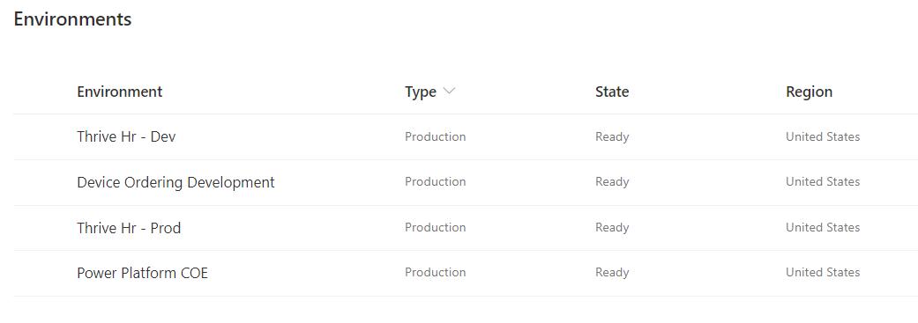

1. Click on the **Type** column again and filter by **Default** and **Production**.

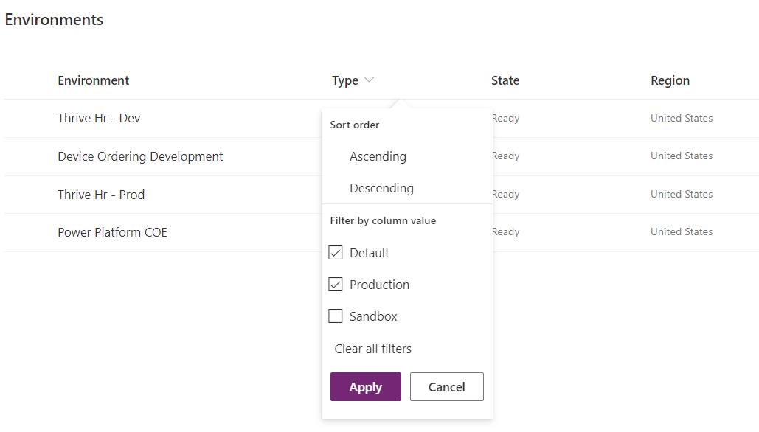

1. You should now see **Production** and **Default** environments.
2. Click on the **Environments** column, select **Sort order** by **Ascending**, and click apply.

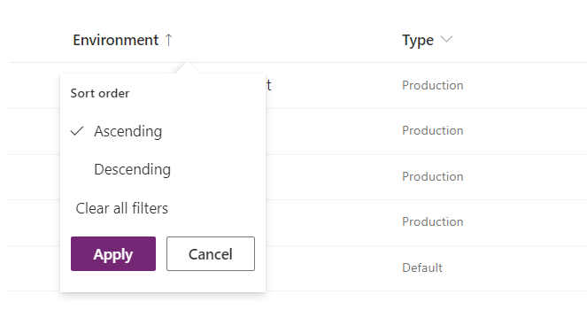

1. The list of environments will show **Production** and *Default* environment ordered by environment name in ascending order.

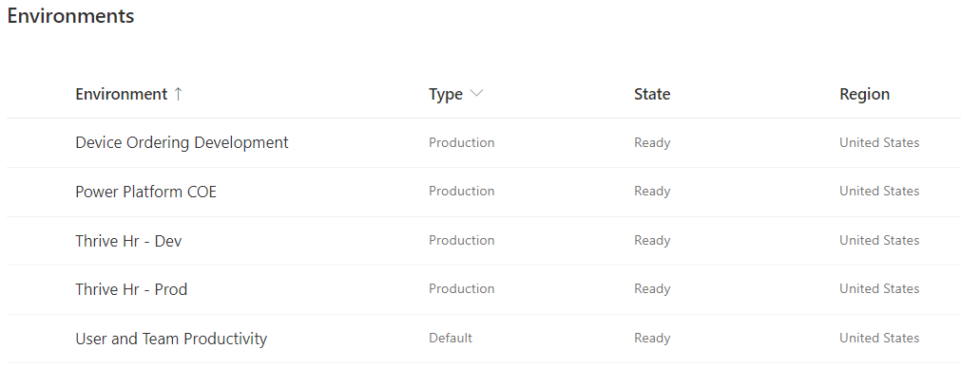

1. Now remove the filters and you should see all environments.
2. Click on the **Type** column again and filter by **Trial**.
3. These environment types are setup by users trying out building apps and flows and they self-service created a trial environment. They will last for 30 days and can be converted to a Production environment prior to expiration if you wish to keep it longer.
4. Click on the environment name to see the details page. If you click on See All in the right corner it will take you to additional details that include how many days left on the trial.

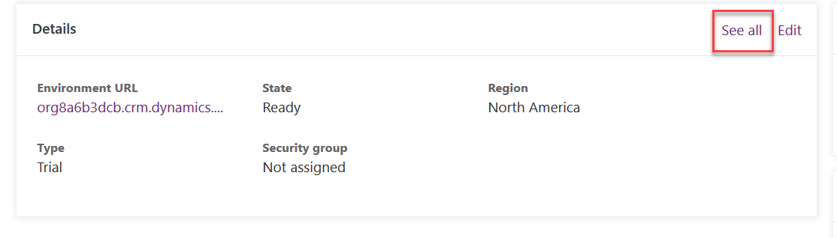

1. Click on Environments to navigate back to the list of environments.

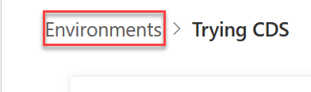

1. Next, notice all the environments with **Thrive HR** in the name. These are a set of environments Contoso uses to manage the lifecycle of their Thrive apps; a suite of employee engagement apps. They are built in Thrive HR - Dev and then are promoted to Test -> UAT-> Production after testing by your admin team.
2. Click on the **Type** and filter by **Default**.
3. This is the environment in which all users are makers and can build their own apps and flows. Think of this environment as supporting personal productivity use of the platform. This is also the default location used by any customizations built with Power Apps in Office apps. The default environment can’t be deleted, but you can rename it to make clear its purpose. For example, some name it *User and Team Productivity* like we have in this tenant.
4. Select the default environment by clicking on the name in the list to drill down into the detail page.

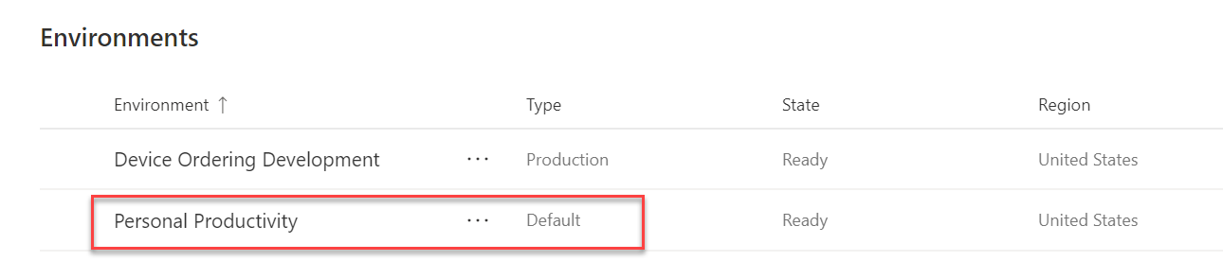

1. In the **Access** section. Notice the two roles that are available.

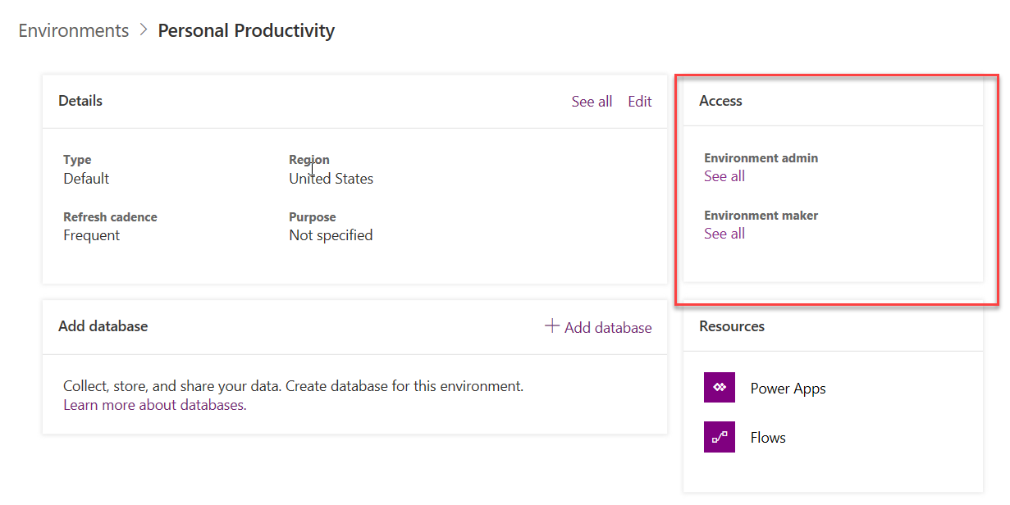

1. Click on **Environment Maker**.

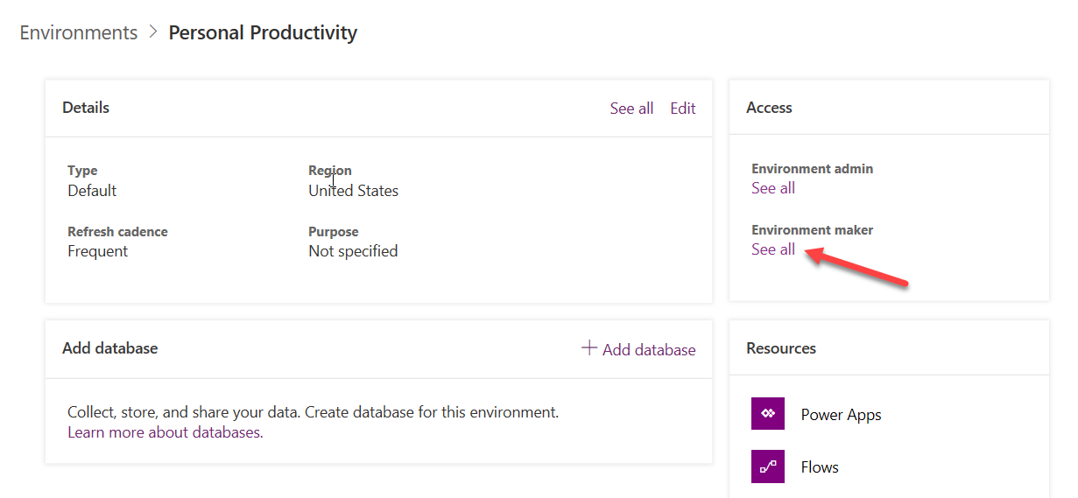

1. Notice Tenant is listed; this means everyone in the tenant has this role. For environments other than default, you control this. However, default is special and Tenant can’t be removed from the role.

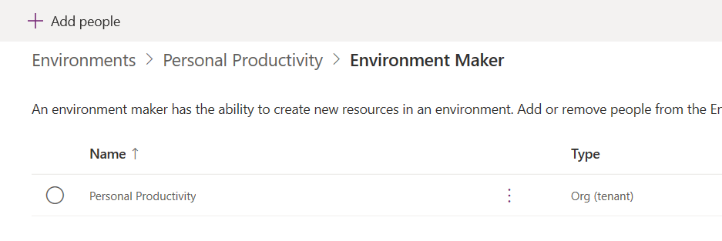

1. Go back and in the **Resources** section, click **Power Apps**.

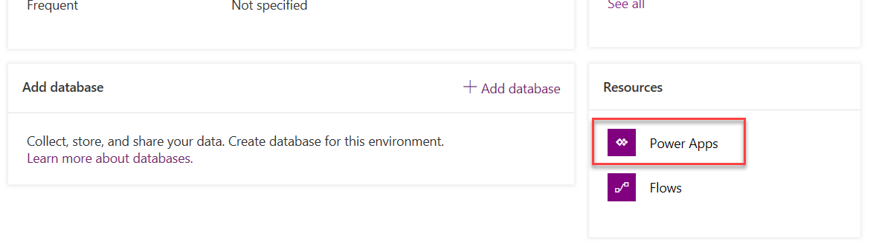

1. These are apps built by users in your default environment. Notice many of them are just test names because this is where a lot of users will experiment and build their first app. As you scroll down the list you might notice some names are more deliberate e.g. Product Showcase. Later in the course we will talk about how to identify these upcoming apps so you can help give them the guidance to ensure they mature and have adequate governance.
2. Click on the … and select Details to view app details, such as app type (standard/premium), web link, connections and shared with information.

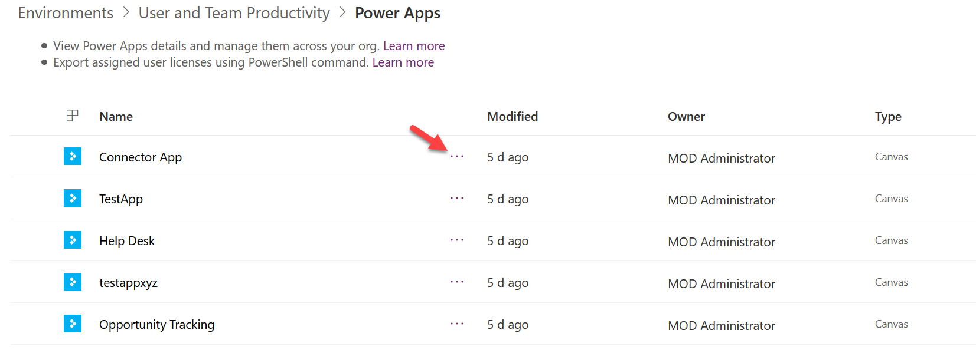

1. Go back to the previous page and click on **Flows** in the **Resources** section and you will notice a similar pattern to apps.

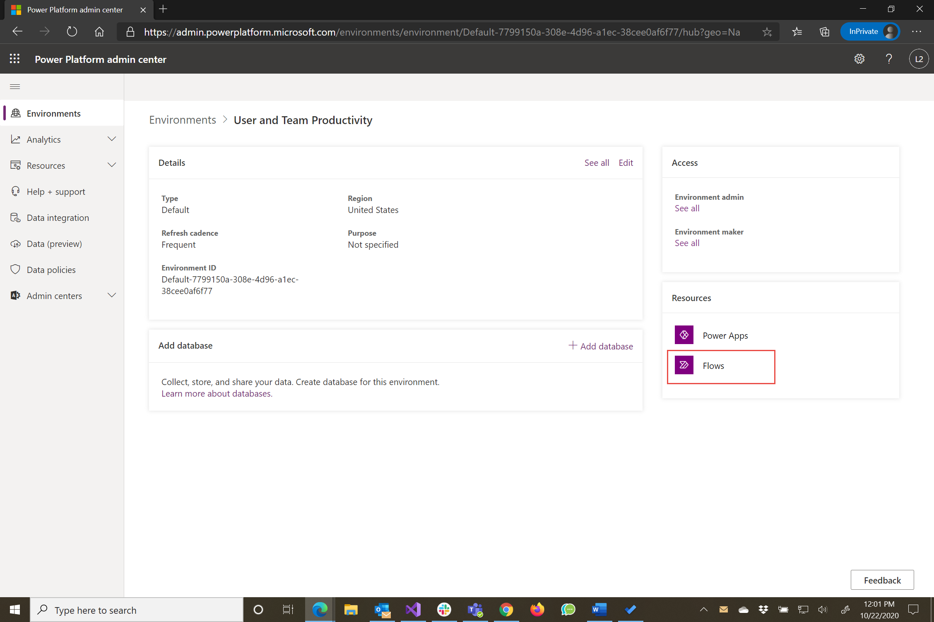

1. From here you can quickly turn off a flow that is active, as well as delete it if necessary.

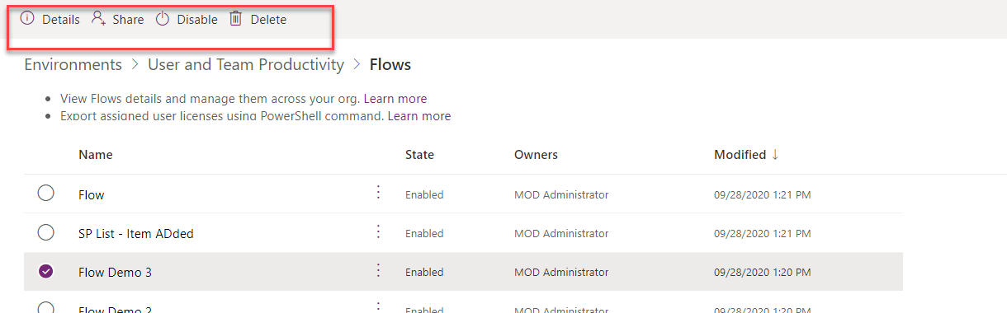

1. Click the **…** button on one of the flows and select **Details**.

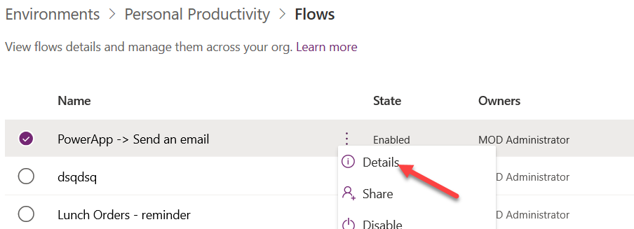

1. From here you can see who created it, who the owner is as well as what connections it is using. You can also view and share the flow with others from here. We will discuss that more later in the course.

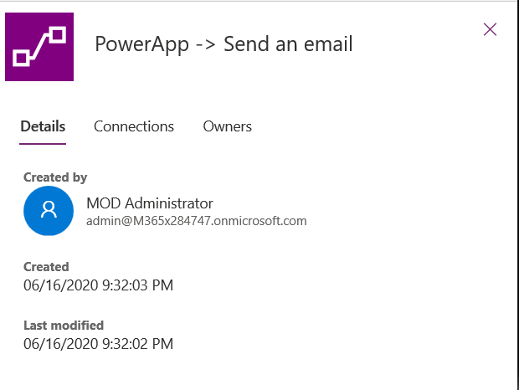

### Task 2: Review existing Data policies

1. Navigate to the admin portal <https://aka.ms/ppac> or <https://admin.powerplatform.microsoft.com>
2. Select **Data policies** on the left navigation.
3. Review the list of existing policies.
   * As the login you are using is not a tenant admin but only an environment admin, you will see policies that impact environments of which you are a member.
   * As an environment admin or regular environment user, you will also be able to see any tenant-wide DLP policies applied to your environment. However, you would not be able to edit those tenant-side DLP policies.
   * As a Global Admin, Admin, Power Platform Service Admin or D365 Service Admin in your tenant, you will see all policies that exist in your tenant, even those that you did not create.
4. Notice the Contoso Global DLP policy exists that is intended to span all environments (except selected ones) and represents the global DLP policy. This will also be applied to new environments. This has been created with a selection of All Environments Except selected.
5. You will also notice a DLP for **Thrive Exceptions**. That team had worked with the IT department to agree on exceptions they need for their environments and their environment would be excluded from the Contoso Global DLP. This exception DLP policy would have their environments included and apply only to them.

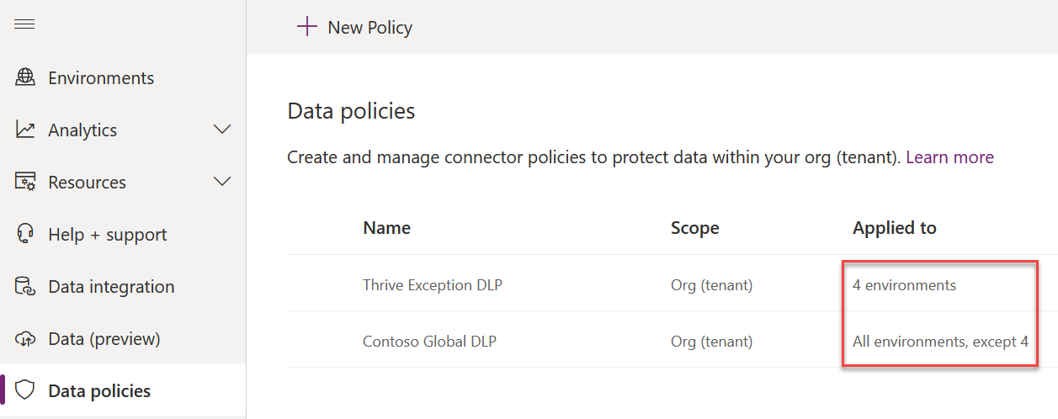

1. Select the **Global DLP** and click **View Policy**.

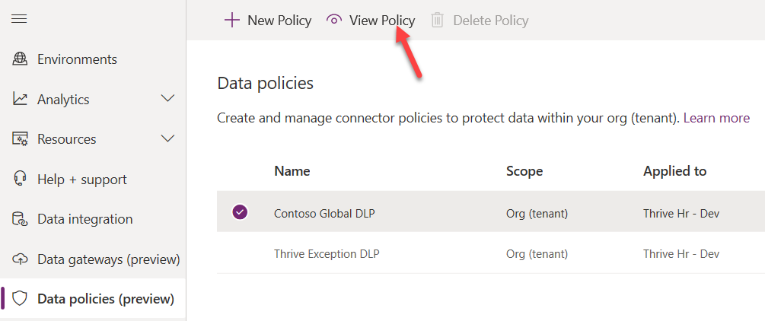

1. Select **Connectors** and review the **Business** connectors.

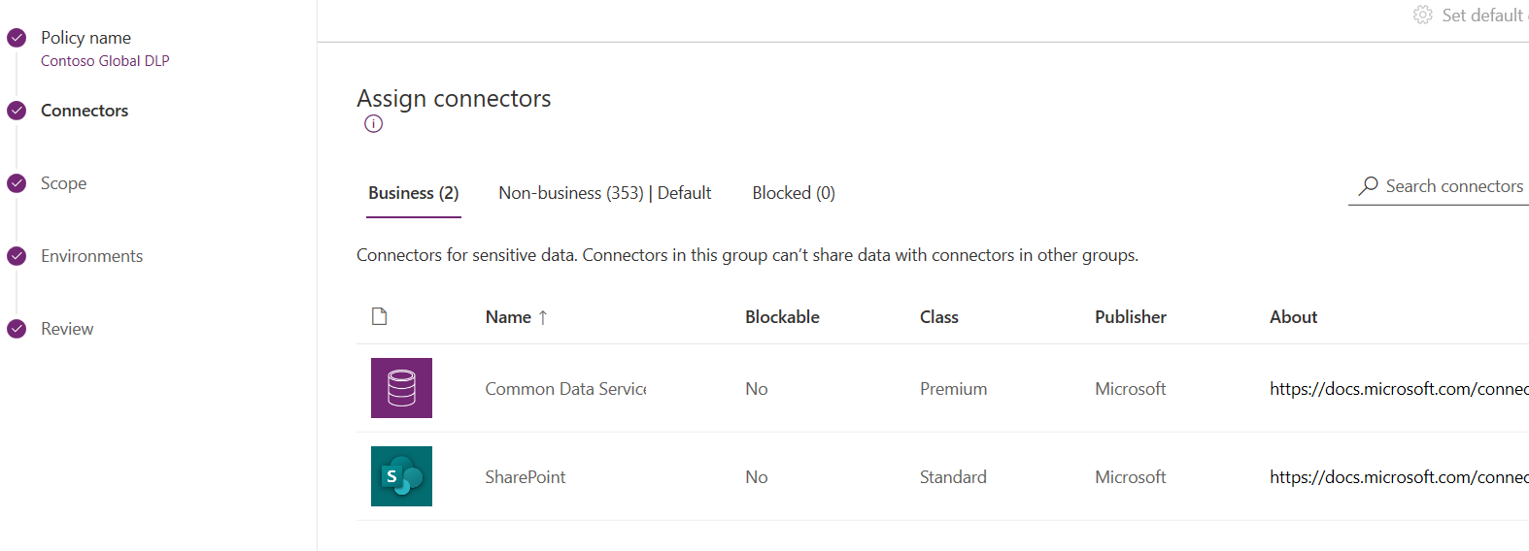

1. Select **Scope** and **Environments** to see how it is configured.
2. Select **Data Policies** again.
3. Select the **Thrive DLP** and click **View Policy**.
4. Click on the **Connectors** and select the **Business** tab. Based on the use case for the Thrive application the connectors in the Business group have been established. You can also see how Scope and Environments are configured to only select the Thrive environments.

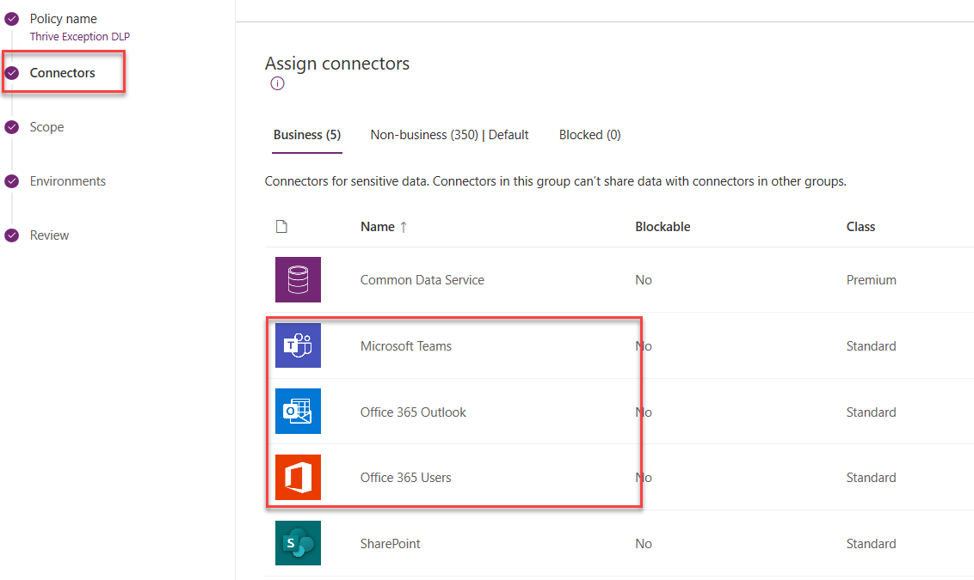

# Exercise 2: Plan an environment strategy

In this exercise, you will be reviewing the scenario for Fabrikam that explains their current situation. After reviewing you will evaluate and propose an environment plan.

### Task 1: Read about the current situation at Fabrikam

In this task, read the following and take notes that would help you propose an environment plan for Fabrikam.

You have recently joined the newly formed Power Platform center of excellence team at Fabrikam and are responsible for establishing a governance strategy. Currently, there is not a governance process established and employees are able to create apps, flows and even environments without any control. Fabrikam has been in existence for 40 years and has 4,500 employees at multiple office locations in the US, UK and EU. Fabrikam employees are all licensed for Office 365 E3 and a growing number of them have either Power Automate or Power Apps per user licenses. Over the last 6 months Fabrikam’s management realized that that this was greatly improving productivity, but they recognize without some planned governance it could easily get out of control. About 50 of the users are more advanced power users of the platform always looking at ways to push its limits. Fabrikam’s sales team of 100 users also use a heavily customized Dynamics 365 Sales app deployment.

One of the first things you did is look in the admin center to see how many environments were there. Currently in the tenant there are 45 environments with a variety of names that users chose. The majority of the applications looked like they were in the default environment or a couple of other custom environments that had been created. There was one environment that was clearly the production Dynamics 365 application environment used by the sales team.

The most organized department is market research, they built an application that is used daily for conducting their market surveys. Currently there is just a single custom environment named Market Research that supports the application. There are a couple of people in the department that are app makers doing all the changes. They tend to do them in the late afternoons and evenings and publish them when nobody's around to avoid impacting other users. There is not currently any testing done before the app is published other than by the person making the changes. They are open to the testing idea but not sure how to do it with a single environment.

You found out that the new environments have stopped being created simply because they have run out of storage from creating too many environments. When you asked about this you were handed a stack of requests that claimed they needed new environments. The following are the priority requests; we will ask you to help identify how to handle these when you fill out the environment strategy template.

* Request 1: A user would like to build a set of Power Automate flows that helps organize their Outlook inbox and tags emails.
* Request 2: VP of Service wants to build some custom apps to support their teams; like how the market research team has done.
* Request 3: Marketing wants to build an app that makes it easy to publish tweets on Twitter using the Twitter connector. They also plan to create Power Automate flows that notify them of mentions along with the sentiment of the message.
* Request 4: HR would like to try the Crisis Comms app that Microsoft published and would like an environment for it to run in.
* Request 5: A user would like to build an app that uses a custom connector for a 3rd party service and also uses the DropBox connector.

Yesterday you got some good news, another 30GB of storage capacity for environments had been procured. You also got permission to put in place the necessary steps to ensure it does not get wasted.

### Task 2: Build an Environment Plan

In this task, you use the information from Task 1’s scenario to help you propose an environment plan for Fabrikam. To help you build the plan we have prepared a worksheet with questions for you to answer.

1. Open **M01 – HOL Environment Worksheet.docx** from the Resources folder and complete it by answering each of the questions. You should spend no more than 10 minutes on this before proceeding to the next task.

### Task 3: Review the example environment plan and compare to yours

In this task, we have provided you with a completed environment plan. Review the answers and compare to the one you built in the prior task.

1. Open the Example Environment Plan document **M01 – HOL Environment Example.docx** and compare the answers to the one you completed in the previous task.
2. Talk to your trainer about any significant differences that do not make sense to you.

# Exercise 3: Plan a DLP strategy

## Scenario

In this exercise, you will be planning a DLP strategy for Fabrikam using the same scenario background information from the last exercise.

### Task 1: Build a DLP Plan

In this task, you use the information from the last exercise’s scenario to help you propose a DLP plan for Fabrikam. To help you build the plan we have prepared a worksheet with questions for you to answer.

1. Open **M01 – HOL DLP Worksheet.docx** from the Resources folder and complete it by answering each of the questions. You should spend no more than 10 minutes on this before proceeding to the next task.

### Task 2: Review the example DLP plan and compare to yours

In this task, we have provided you with a completed environment plan. Review the answers and compare to the one you built in the prior task.

1. Open the Example Environment Plan document **M01 – HOL DLP Example.docx** and compare the answers to the one you completed in the previous task.
2. Talk to your trainer about any significant differences that do not make sense to you.

# Exercise 4: Evaluate impact of adding DLP

## Scenario

In this exercise, you will be creating an environment, creating a flow, and then viewing the impact of adding a DLP policy.

### Task 1: Create a trial environment

1. Navigate to [Power Platform admin center](https://admin.powerplatform.microsoft.com/) .
2. Select **Environments** and click **+ New**.

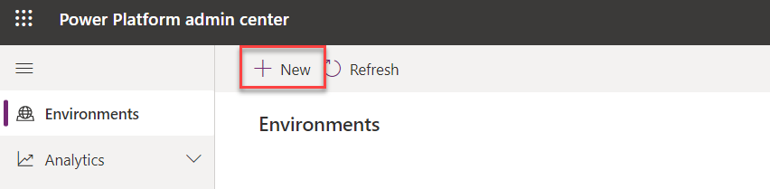

1. Enter **My Sandbox (Your initials)** for **Name**, select **Trial** for **Type**, select your **Region**, select **Yes** for **Create a database for this environment**, and click **Next**.

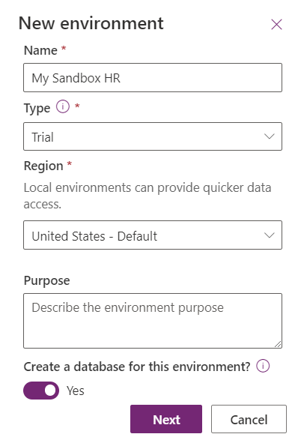

1. You may provide a **URL**, select **Currency**, and click **Save**.
2. Wait for the environment to be created. The state will change to **Ready** when the environment is ready.

### Task 2: Create a flow to get the weather

1. Navigate to [Power Apps maker portal](https://make.powerapps.com/) and select the environment you created.

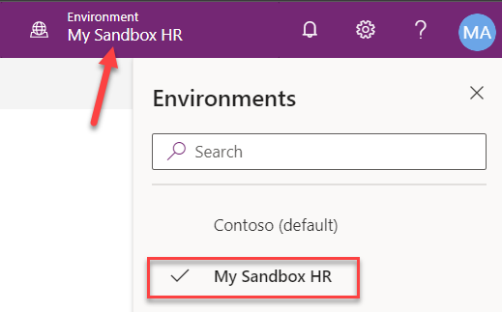

1. Select **Flows** from the left.
2. Click **+ New** and select **Scheduled – from blank**.

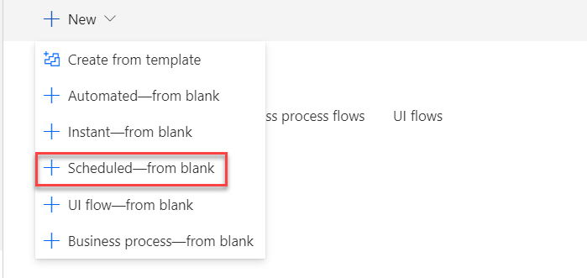

1. Enter **Weather flow** for **Name**, select **Repeat every 1 Day**, and click **Create**.

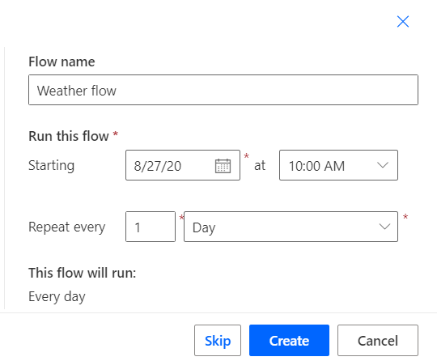

1. Click **+ New step**.
2. Search msn and select **Get current weather** **MSN Weather**.
3. Provide your **Location**, select your preferred **Units**, and click **+ New step**.

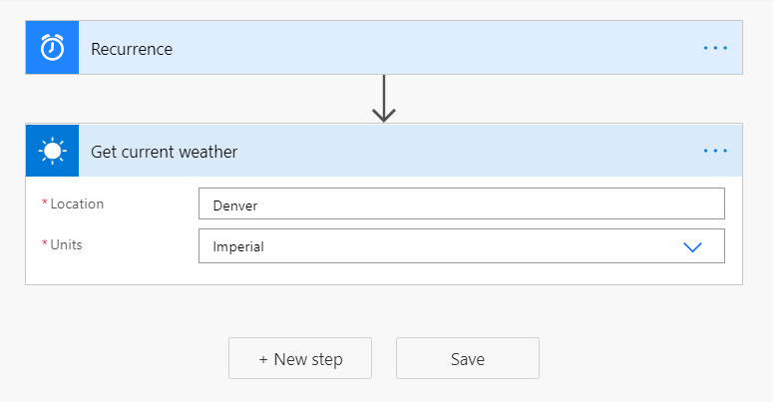

1. Search for send email and select **Send an email (V2) Office 365 Outlook**.
2. Provide your email for **To** and enter **Current Weather** for **Subject**.
3. Click on the Body enter **Current weather for:** and select **Location** from the Dynamic content pane.

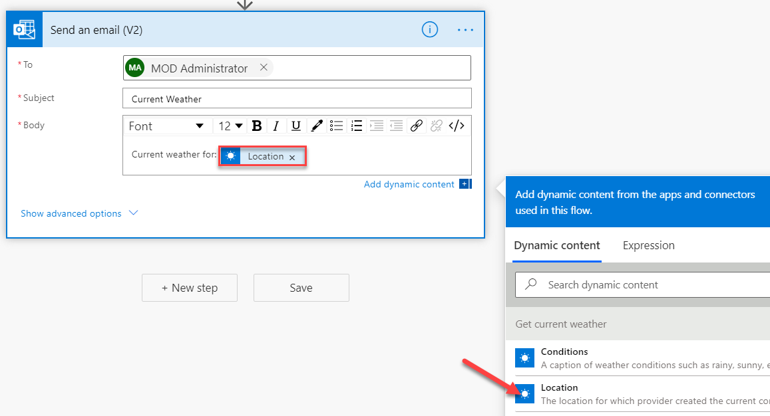

1. Hit the **[ENTER]** key**,** enter **Temperature:** and select **Temperature** form the Dynamic content pane.
2. Hit the **[ENTER]** key**,** enter **Conditions:** and select **Conditions** form the Dynamic content pane.
3. You may add other values to the email.
4. Click **Save**.

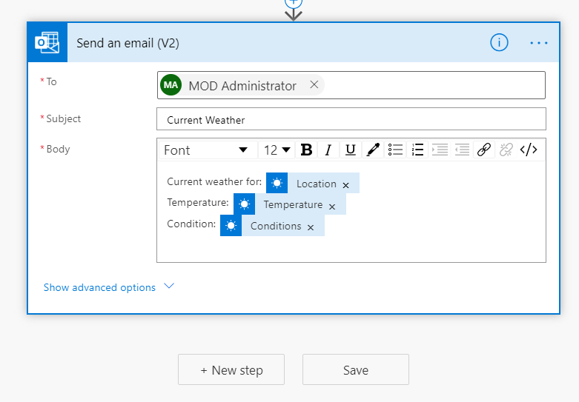

1. Go to My flows by clicking on the 🡨 button located on the top left of the page.

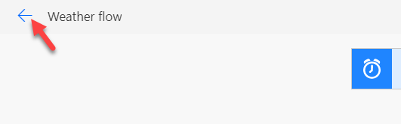

1. Click to open the flow.
2. Click **Run**.

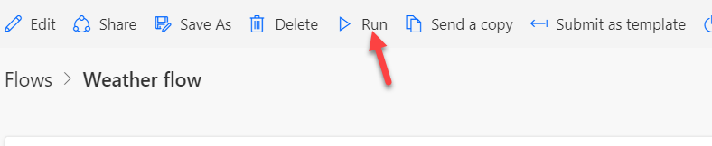

1. Click **Run flow**.
2. Click **Done** and wait for the flow run to complete. Click on the Refresh button to see the update status.

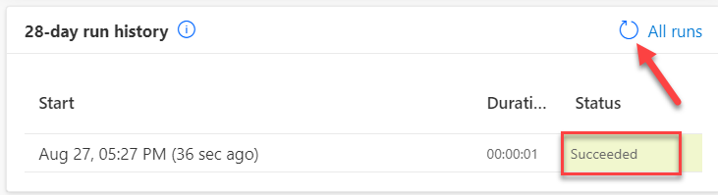

1. Navigate to [**Outlook**](https://outlook.office.com/) .
2. You should get an email with the weather information.

### Task 3: Create a DLP Policy

In this task you will create an environment specific DLP and see how it impacts your working flow.

1. Navigate to [Power Platform admin center](https://admin.powerplatform.microsoft.com/) .
2. Select **Data policies** and click **+ New Policy**.
3. Enter **My Sandbox (Your initials)** for **Name** and click **Next**.
4. Search for common data, select **Dataverse (current environment)**, and click **Move to Business**. Choose carefully, you may have to expand the Name column to differentiate between connectors in your search results.

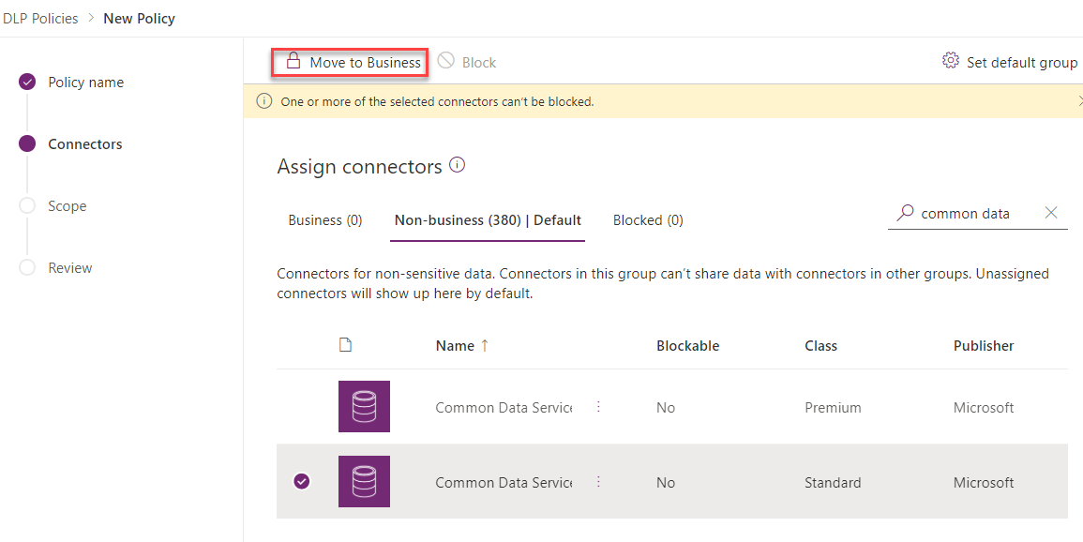

1. Search for SharePoint, select **SharePoint,** and click **Move to Business**.
2. Search for Outlook, select **Office 365 Outlook,** and click **Move to Business**.
3. Select the **Business** tab.
4. You should now have three connectors moved to Business. Click **Next**.

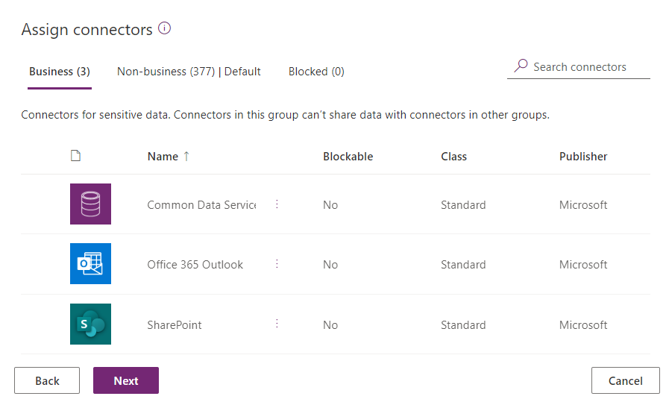

1. Select your environment and Add to policy.

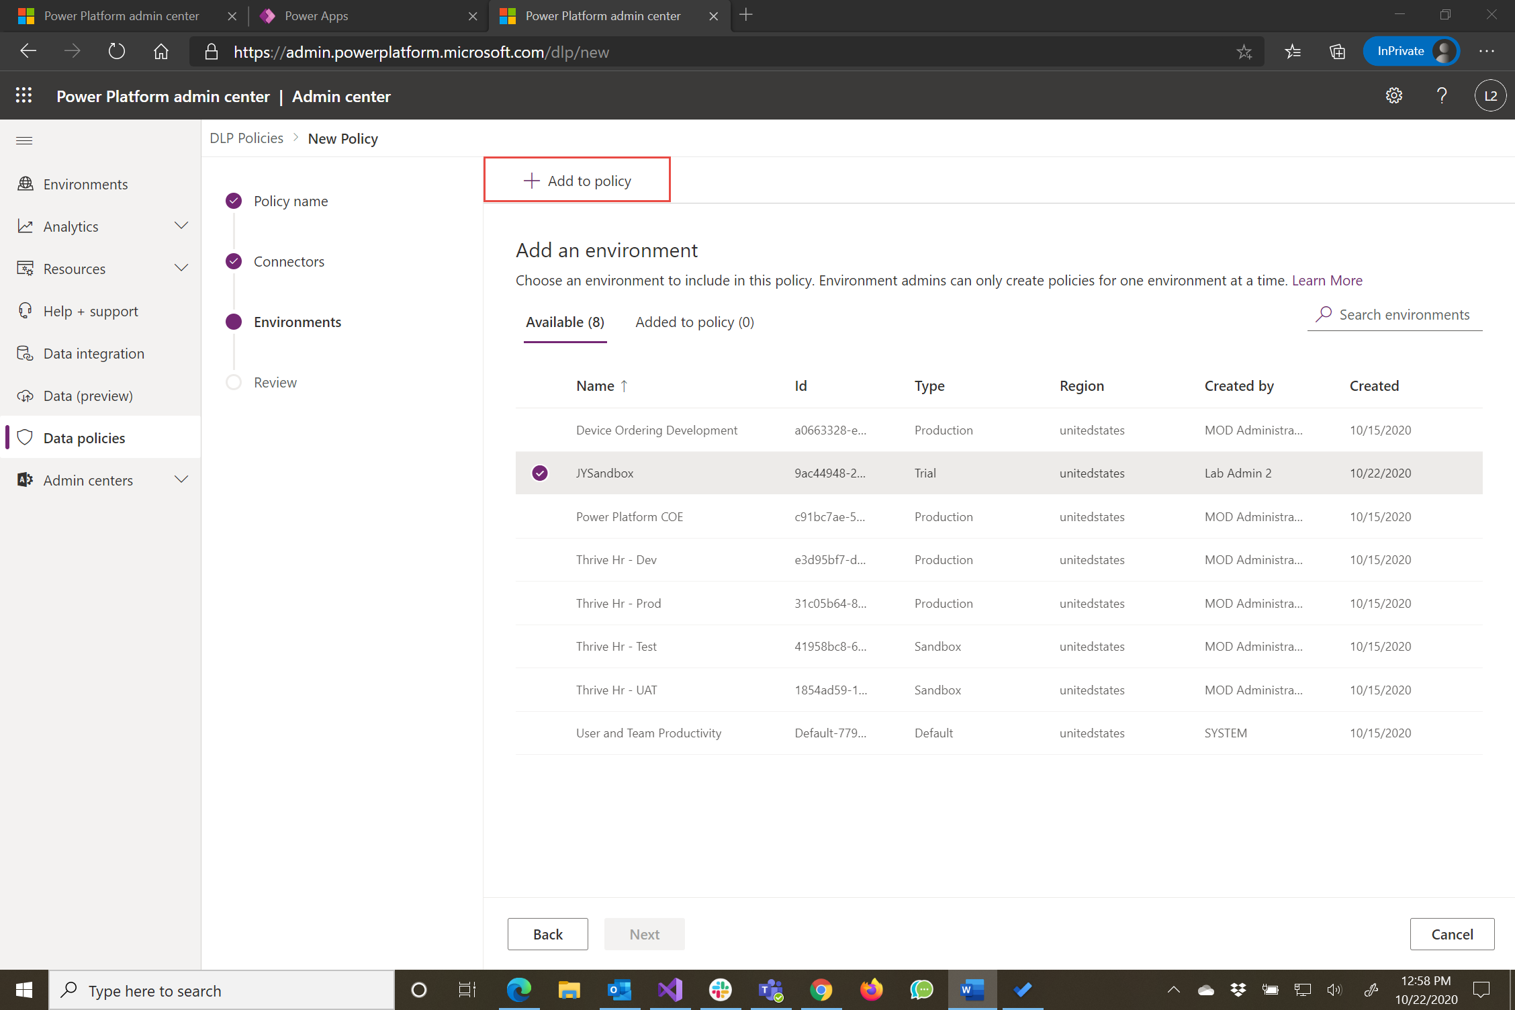

1. Click **Next** again.
2. Click **Create policy**.
3. Navigate to [Power Automate.](https://flow.microsoft.com/)
4. Select My flows.
5. The flow should now be suspended because of the DLP you created. Click to open the flow. This can take up to 5 minutes, wait few minutes and then click refresh.

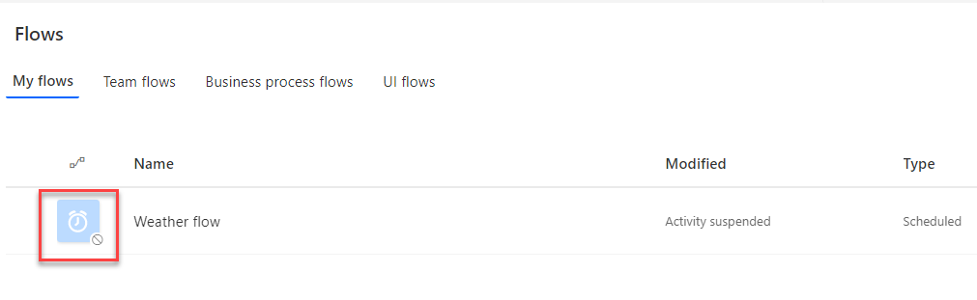

1. You should not be able to run the flow.

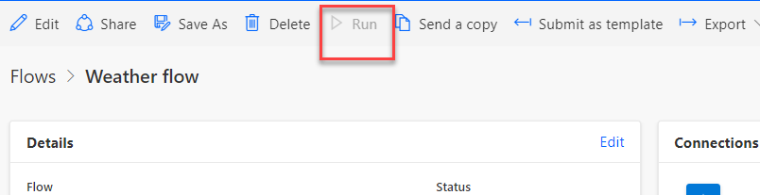

**Note:** After you finish this lab if you have time come back and modify the DLP you created to fix the problem. If you have trouble getting it to work, ask your instructor for some tips.

# Exercise 5: Configure a security role

## Scenario

In this exercise, you are going to import a pre-built Power Apps canvas app that was built in another environment. The application allows users to see a list of Projects stored in Dataverse. After importing you will build a Security Role to allow users to work with the Project entity data. Finally, you will see how to share the application with an Azure AD Security group and assign the security role you just built.

### Task 1: Import project management solution

1. Navigate to [Power Apps maker portal](https://make.powerapps.com/) and select The My Sandbox environment you created.

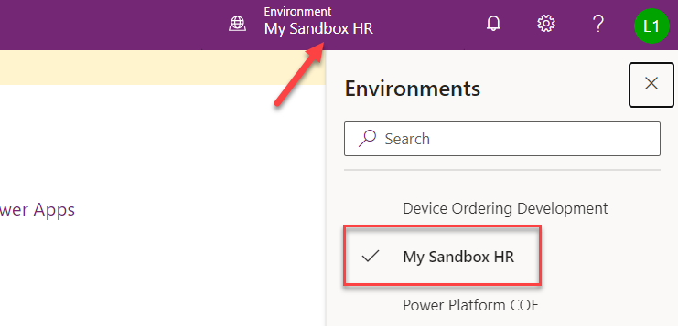

1. Select **Solutions** and click **Import**.

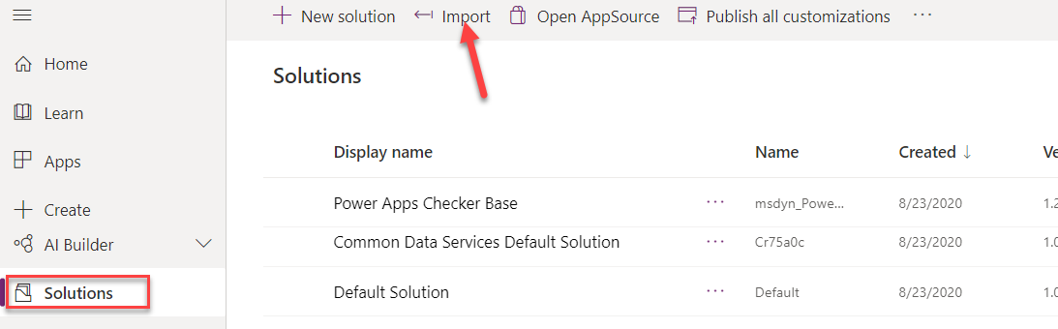

1. Click **Browse**.
2. Select the **Fabrikam Project Management** solution located in the lab resources folder and click **Open**.
3. Click **Next**.

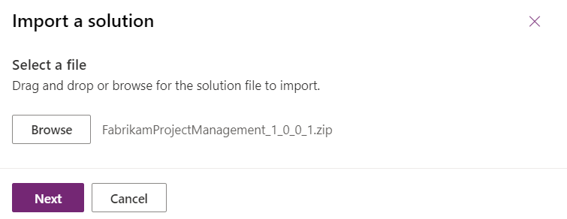

1. Click **Import** and wait for the import to complete. You should get a notification when the import succeeds.
2. Click **Publish All Customizations** and wait for the publishing to complete.

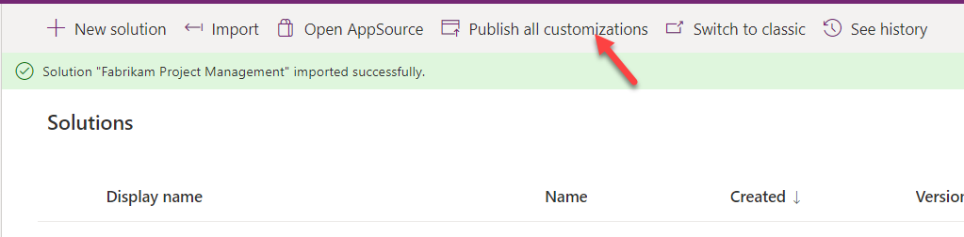

1. Click to open the solution you just imported.

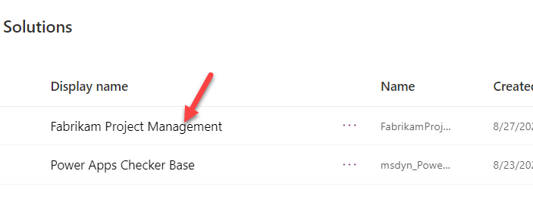

1. The solution should have four components; a custom connector, an entity named project, a canvas app named project list, and a flow. Click to open the **Import Sample Data – Projects** flow. You are going to run this flow to insert some sample project data for the app to use.

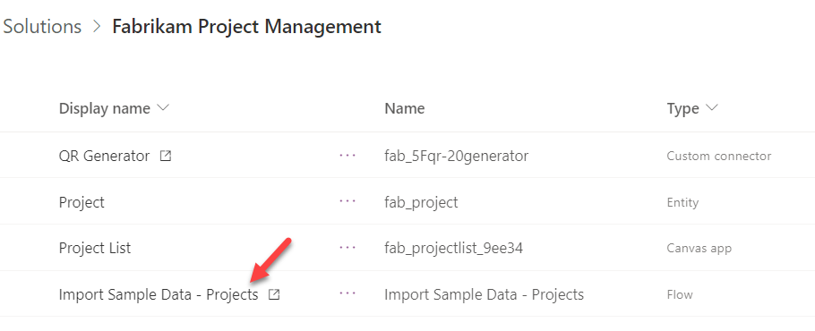

1. Click **Edit**.

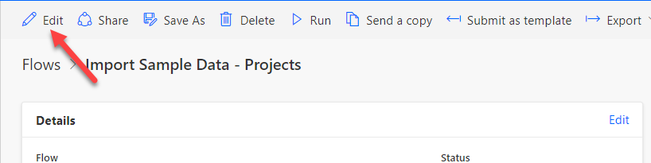

1. Click **Continue**.

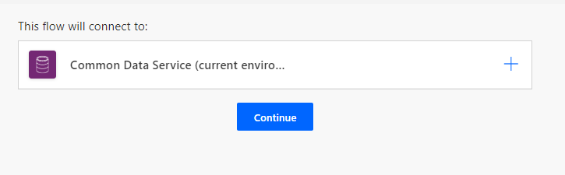

1. Click to expand the **Parse JSON** step.
2. Examine the sample records the flow will create.
3. Click **Save**.
4. Go back to the details view of the flow by clicking on the 🡨 button.
5. Click **Run** to run the flow.
6. Click **Run flow**.
7. Click **Done** and wait for the run to complete.

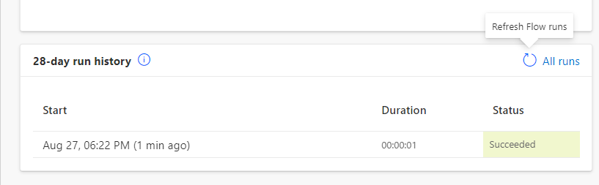

1. Close the Power Automate browser window or tab.
2. Click **Done**.

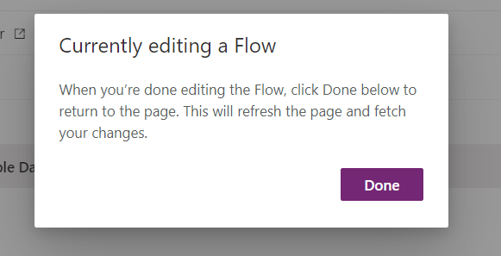

1. Select **Apps** and click to open the **Project List** canvas application.

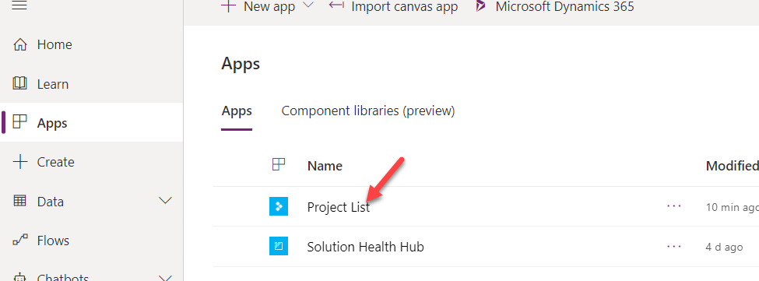

1. The application should load, and you should see the sample project records the flow created. Click +.

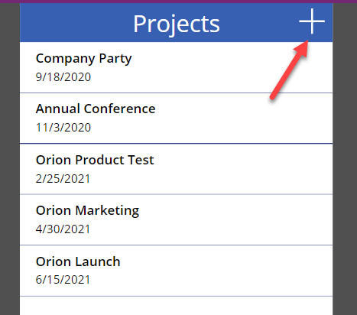

1. Enter **Test Project** for **Title**, select **Due date** and click **Submit**.

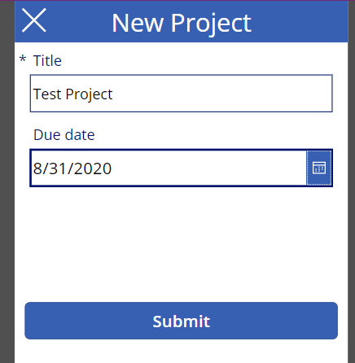

1. The application should create the new record and take you back to the list of projects.

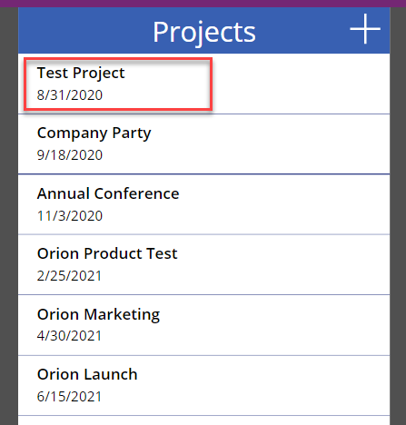

1. Close the Project List application browser window or tab.

### Task 2: Create a security role

1. Navigate to [Power Apps maker portal](https://make.powerapps.com/) and make sure you have your sandbox environment selected.
2. Select **Solutions** and click to open the **Fabrikam Project Management** solution.
3. Click **+ New** and select **Other** | **Security role**.

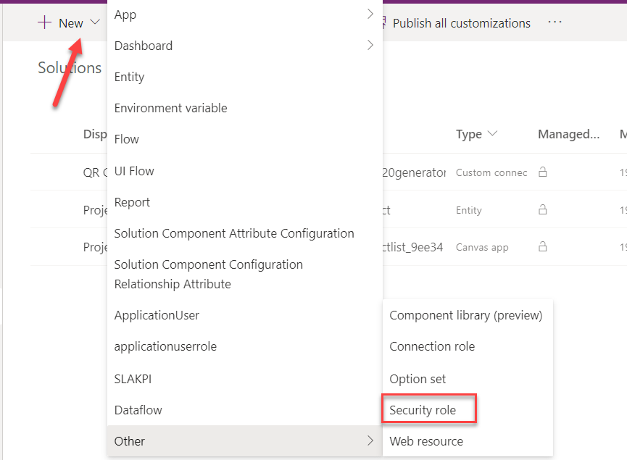

1. Enter **Project Manager** for **Role Nam**e and click **Save**.
2. Select the **Custom Entities** tab.
3. Scroll down to locate the Project entity and click on the name of the entity.

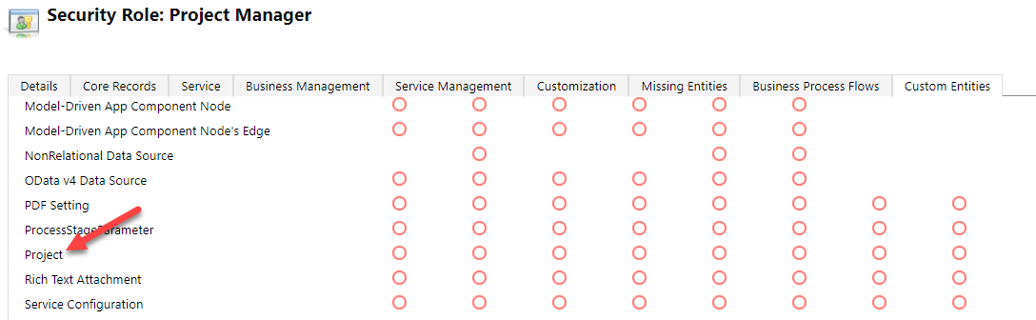

1. This action will give this role User rights to the Project entity. If you kept clicking on the label it would increase the permissions with each click till the user had full privileges.

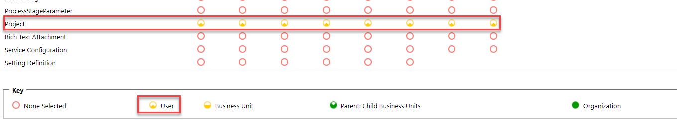

1. You will now give this role organization read privilege. Click on the second dot from the left. You can also scroll up and see the column headers.

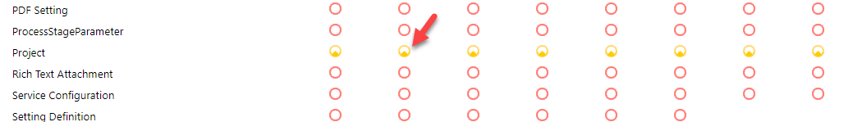

1. Click on the same dot two more times or until the dot is totally filled. This will allow any user with this role to see all project records in the Dataverse environment.

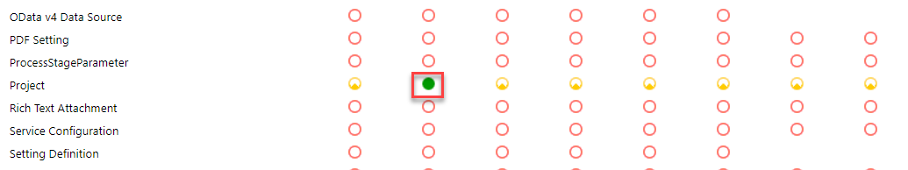

1. Click **Save and Close**.
2. Click **Done**.
3. Click **Publish all customizations** and wait for the publishing to complete.
4. Do not navigate away from this page.

### Task 3: Share app

1. Select **Apps**, select **Project List application**, and click **Share**.

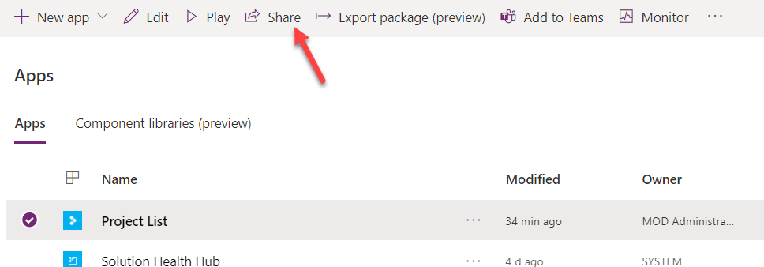

1. Search for lab back office and select Lab Back Office group.
2. Click on the **Assign a security** role dropdown.

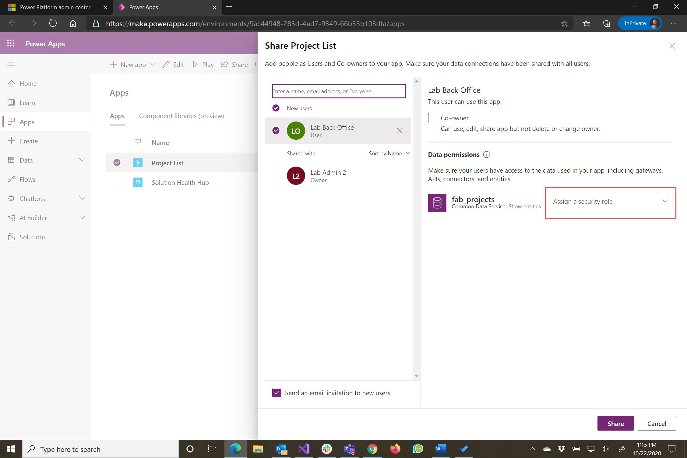

1. Select the **Project Manager** and **Dataverse User** roles and then click **Share**.

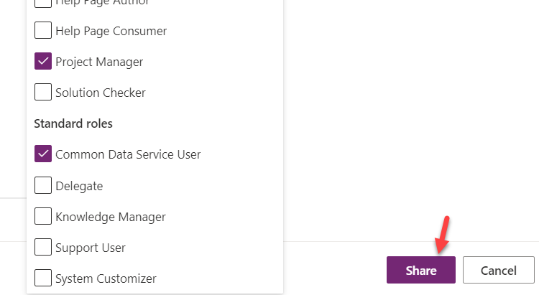

1. Close the share pane.